Python Masterclass

Introduction to Python
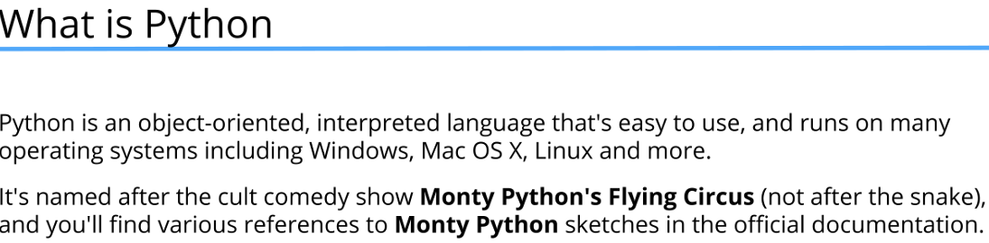
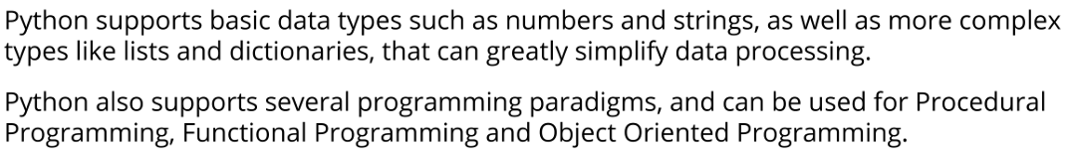
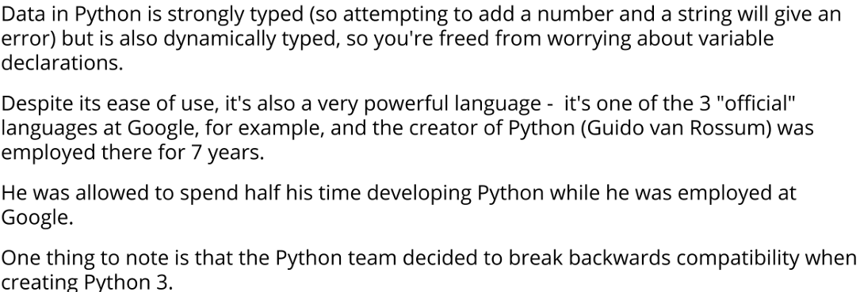
First Program “Hello, World!”

#print is a built-in function in Python that outputs text to the console.
print("Hello, World!") # Hello World

Printing in Python

print("Hello, World!") # Hello World
print(1 + 2) # 3
print( 7 * 6 ) # 42
print() # prints a blank line
print("The End", "or is it?", "keep watching to learn more about Python", 1)
# The End or is it? keep watching to learn more about Python 1

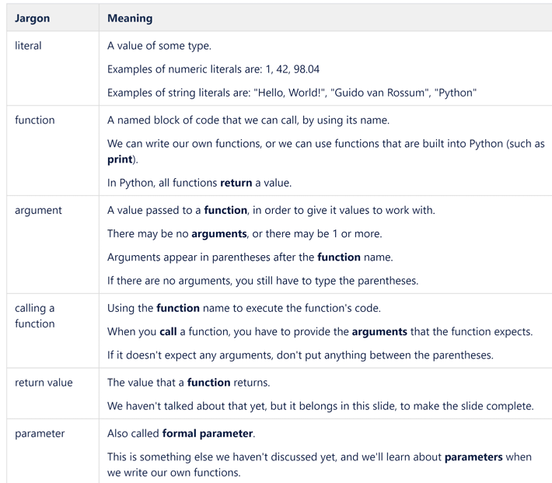
Strings, concatenation, input function

print("Today is a good day to learn Python.")
#Today is a good day to learn Python.
print("Python is fun") # Python is fun
print("Python's strings are easy to use.") # Python's strings are easy to use.
print('You can even include "quotes" in strings.') # You can even include
#"quotes" in strings.

#String concatenation: joining strings together
print("Hello, " + "world!") # Hello, world!

#We can also use variables to store strings
greeting = "Hello"
name = "Alice"
print(greeting + ", " + name + "!") # Hello, Alice!

# input function is used to take user input. It reads a line from input,
# converts it into a string and returns it.
user_name = input("Enter your name: ")
print("Welcome, " + user_name + "!")

Escape Characters

# \n is the escape character for a new line in Python strings.
split_string = "This string has been\n split on\n several lines."
print(split_string)
# This string has been
# split on
# several lines.

# \t is the escape character for a tab in Python strings.
tabbed_string = "1\t2\t3\t4\t5"
print(tabbed_string) # 1 2 3 4 5

# you can use \ to escape characters in strings like single
# and double quotes.

print('The pet shop owner said "No, no, \'e\'s uh,...he\'s resting".')
# The pet shop owner said "No, no, 'e's uh,...he's resting".
print("The pet shop owner said \"No, no, 'e's uh,...he's resting\".")
# The pet shop owner said "No, no, 'e's uh,...he's resting".

# if you use triple quotes, you don't need to escape single
# or double quotes inside the string.
print("""The pet shop owner said "No, no, 'e's uh,...he's resting". """)
# The pet shop owner said "No, no, 'e's uh,...he's resting".

# Triple quotes can also be used to create multi-line strings
another_split_string = """This string has been
split over
several lines."""

print(another_split_string)
#This string has been
#split over
#several lines.

#you can also use / to escape new line characters in your triple
#quoted strings.
yet_another_split_string = """This string has been \
split over \
several lines."""
print(yet_another_split_string)
#This string has been split over several lines.

#Escape character for backslash

# To include a backslash in a string, you need to escape it
# with another backslash.
print("C:\\Users\\Temp\\Documents") # C:\Users\Temp\Documents
# Alternatively, you can use raw strings by prefixing the string
# with 'r' to avoid escaping backslashes.
print(r"C:\Users\Temp\Documents") # C:\Users\Temp\Documents

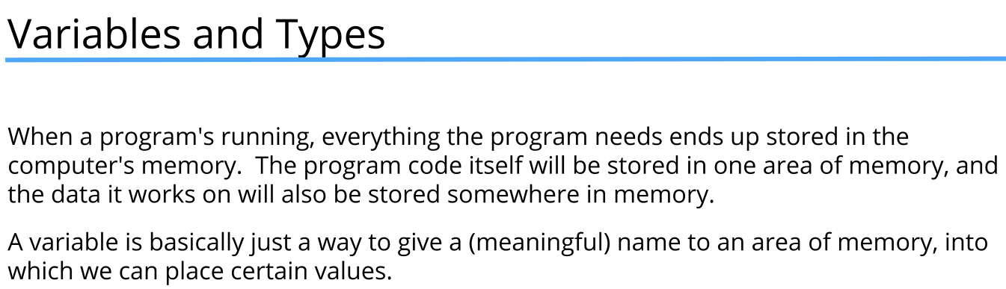
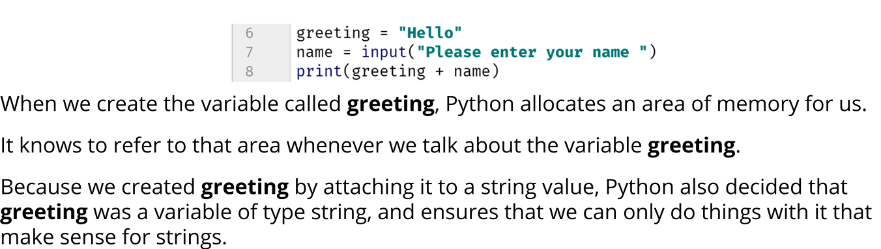
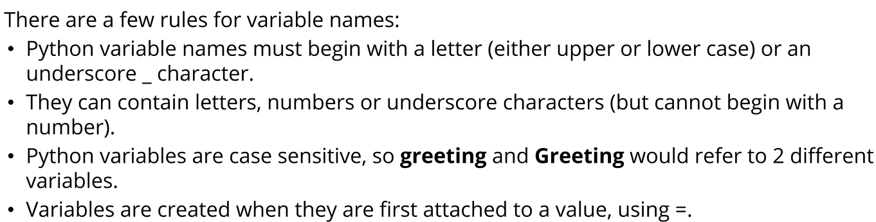
Python Data Types

greeting = "Hello"
name = "Marian"
age = 24

print(type(greeting)) # <class 'str'>
print(type(age)) # <class 'int'>

#Data type represent the type of value a variable holds.

#Python is a dynamically typed language, meaning you don't need to declare
#the data type of a variable explicitly. The interpreter infers the type
#based on the value assigned to the variable. So its more like the value has
#the type rather than the variable itself. But it also mean that you can
#reassign a variable to a value of a different type later in the code.

age = "2 years"

print(age) # 2 years
print(type(age)) # <class 'str'>

age = 24

#Python is strongly typed, meaning that it enforces type constraints.
#You cannot perform operations that are not supported between different
#data types without explicit conversion. For example, you cannot concatenate
#a string and an integer directly.
print(name + " is " + age + " years old.") # This will raise a TypeError
# TypeError: can only concatenate str (not "int") to str

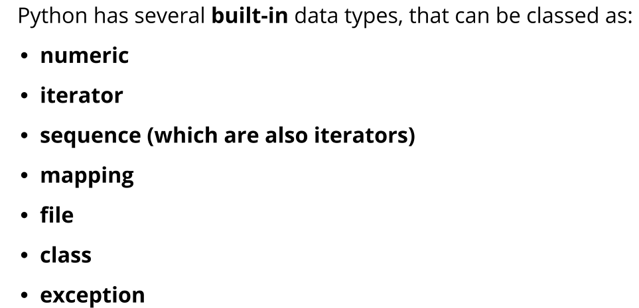

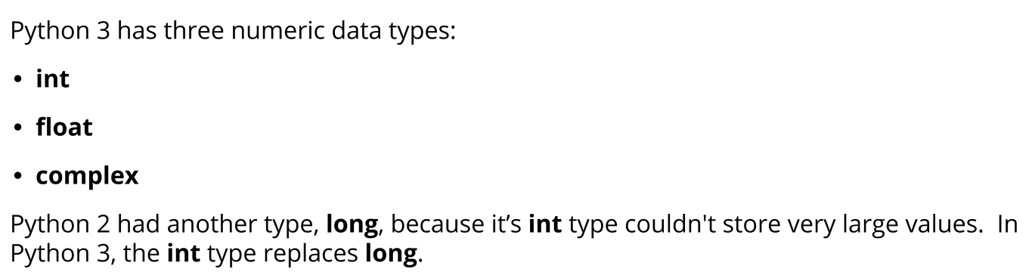
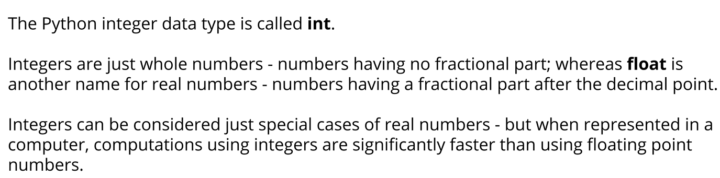
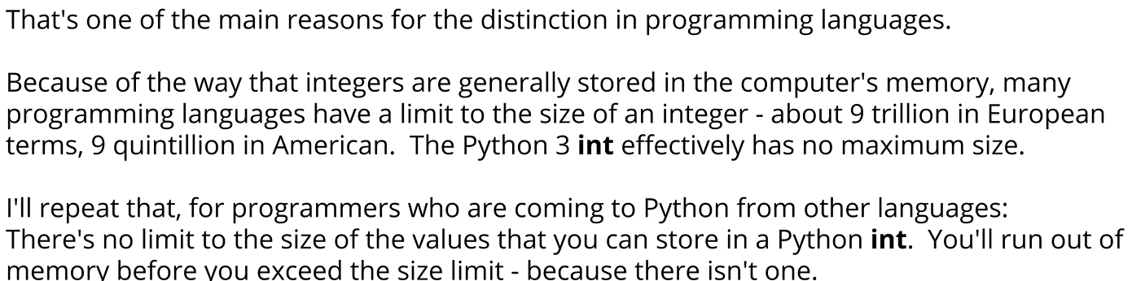
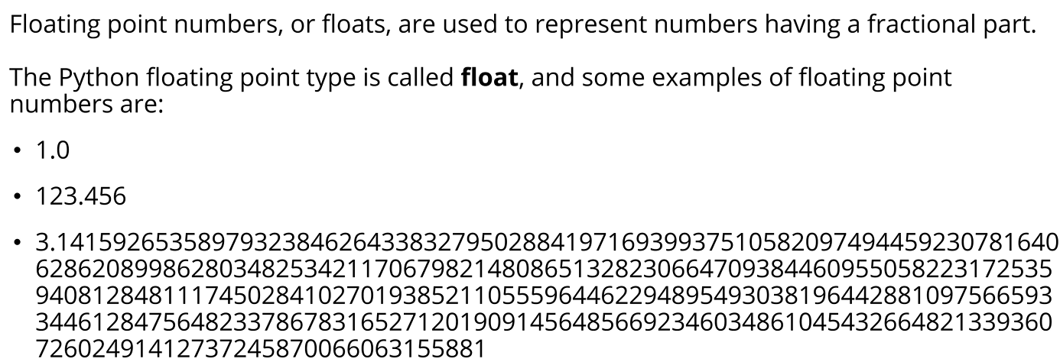

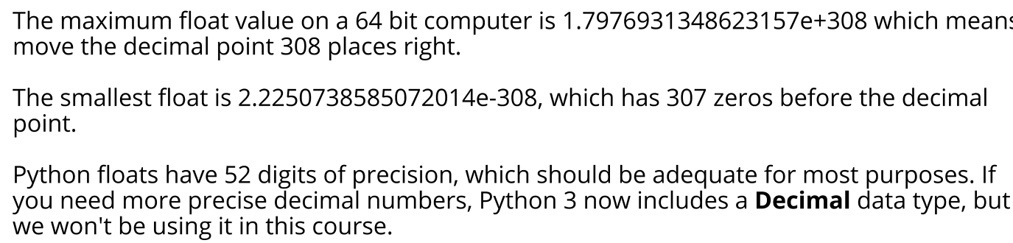
Mathematical operators

a = 12
b = 3

# Addition
print(a + b) # Output: 15

# Subtraction
print(a - b) # Output: 9

# Multiplication
print(a * b) # Output: 36

# Division
print(a / b) # Output: 4.0

# Integer Division: rounds down to the nearest whole number
print(a // b) # Output: 4

# Modulus: returns the remainder of the division
print(a % b) # Output: 0

Expressions

# Expression in Python is anything that can be evaluated to produce a value.
# This includes literals, variables, operators, function calls,
# calculations, and more.

for i in range(1, 4):
print(f"Current number is: {i}") # Outputs: Current number is: 1, 2, 3

i = 1
print(i) # Outputs: 1
i = 2
print(i) # Outputs: 2
i = 3
print(i) # Outputs: 3

Operators precedence

a = 12
b = 3

print(a + b / 3 - 4 * 12) # Output: -35.0
print(a +(b / 3) - (4 * 12)) # Output: -35.0
print((((a + b) / 3) - 4) * 12) # Output: 12.0

c = a + b
d = c / 3
e = d - 4

print(e * 12) # Output: 12.0

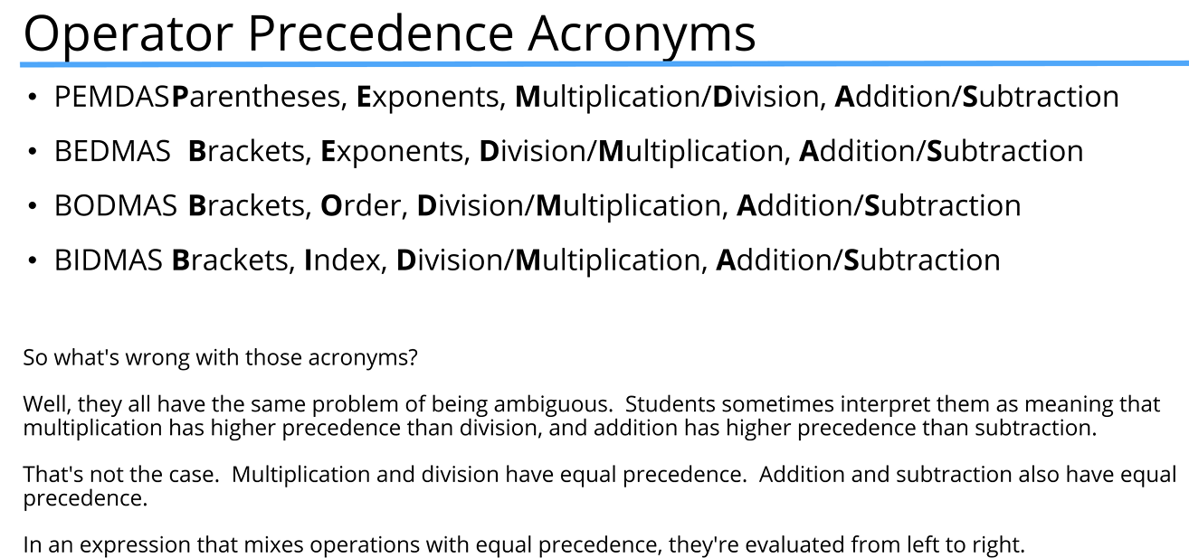
String indexes

#Strings are sequence of characters used to store and
# represent text-based data.
#In Python, strings are indexed, meaning each character
# in a string has a unique position or
# index that can be used to access or manipulate it.
#String indexing starts at 0 for the first character,
# 1 for the second character, and so on.

#012345678910111213
parrot = "Norwegian Blue"

print(parrot) # Output: Norwegian Blue
#Accessing character on fourth position using bracket notation
#and index 3
print(parrot[3]) # Output: w

#print(parrot[16]) # This will raise an IndexError:
#string index out of range
#because the index 16 is out of range for the string "Norwegian Blue"

#Challenge: print we win, each character on a new line
print(parrot[4]) # Output: e
print(parrot[9]) # Output:
print(parrot[3]) # Output: w
print(parrot[6]) # Output: i
print(parrot[8]) # Output: n

#String negative indexes
# In Python, strings can also be indexed using negative numbers.
# Negative indexing allows you to access characters from the end of the string,
# where -1 refers to the last character, -2 to the second last, and so on.

parrot = "Norwegian Blue"

print(parrot[-1]) # Output: e
print()
#Challenge: print we win, each character on a new line using negative indexes

print(parrot[-11]) # Output: w
print(parrot[-10]) # Output: e
print(parrot[-5]) # Output:
print(parrot[-11]) # Output: w
print(parrot[-8]) # Output: i
print(parrot[-6]) # Output: n

#Negative index can be uptained by subtracting the
# length of the string from the positive index.
print()
print(parrot[3 - 14]) # Output: w
print(parrot[4 - 14]) # Output: e
print(parrot[9 - 14]) # Output:
print(parrot[3 - 14]) # Output: w
print(parrot[6 - 14]) # Output: i
print(parrot[8 - 14]) # Output: n

#String Slices
# In Python, you can extract a portion of a string using slicing.
# Slicing allows you to specify a start and end index to create a substring.
# Slicing has three components: start index, end index, and step (optional).
# The character at the end index is not included in the slice.
# if no step is provided, it defaults to 1.
# if no start index is provided, it defaults to 0.
# if no end index is provided, it defaults to the length of the string.
#012345678911234
parrot = "Norwegian Blue"
# Use slice and create substring from index 0 to 6 (not including 6)
print(parrot[0:6]) # Output: Norweg
print(parrot[3:5]) # Output: we
print(parrot[0:9]) # Output: Norwegian
print(parrot[:9]) # Output: Norwegian

String slices

#String Slices
# In Python, you can extract a portion of a string using slicing.
# Slicing allows you to specify a start and end index to create a substring.
# Slicing has three components: start index, end index, and step (optional).
# The character at the end index is not included in the slice.
# if no step is provided, it defaults to 1.
# if no start index is provided, it defaults to 0.
# if no end index is provided, it defaults to the length of the string.
#012345678911234
parrot = "Norwegian Blue"
# Use slice and create substring from index 0 to 6 (not including 6)
print(parrot[0:6]) # Output: Norweg
print(parrot[3:5]) # Output: we
print(parrot[0:9]) # Output: Norwegian
print(parrot[:9]) # Output: Norwegian

#Challenge: print Blue using slicing
print(parrot[10:]) # Output: Blue
print(parrot[10:14]) # Output: Blue
print(parrot[-4:]) # Output: Blue

print(parrot[:6]) # Output: Norweg
print(parrot[6:]) # Output: ian Blue

print(parrot[:]) # Output: Norwegian Blue
print(parrot[:6] + parrot[6:]) # Output: Norwegian Blue

#012345678911234
parrot = "Norwegian Blue"

# Python slicing reminder:
# sequence[start : stop : step]
#
# Default step is +1 (left → right):
# - start index must be LEFT of stop index
# - otherwise, slice is empty
# e.g. text[-4:12] -> works
# text[-4:2] -> empty
#
# Reverse slicing:
# - use a negative step (-1)
# - start index must be RIGHT of stop index
# e.g. text[-4:2:-1] -> works
#
# Negative indexes are resolved first,
# then slicing direction rules are applied.

print(parrot[-4:2]) # Output:
print(parrot[-4:2:-1]) # Output: B naigew

print(parrot[-4: -2]) # Output: Bl
print(parrot[-4: 12]) # Output: Bl

#Challenges
print(parrot[:6]) # Output: Norweg
print(parrot[-14:-8]) # Output: Norweg

print(parrot[3:5]) # Output: we
print(parrot[-11: -9]) # Output: we
print(parrot[0:9]) # Output: Norwegian
print(parrot[-14:-5]) # Output: Norwegian
print(parrot[10:]) # Output: Blue
print(parrot[-4:]) # Output: Blue
print(parrot[6:]) # Output: ian Blue
print(parrot[-8:]) # Output: ian Blue

#Step in slices
#Default value for step is 1

#012345678911234
parrot = "Norwegian Blue"

print(parrot[0:6:2]) #Nre
print(parrot[0:6:3]) #Nw

number = "9,223;372:036 854,775:807"
print(number[1::4]) #,;: ,:
separators = number[1::4]
print(separators) #,;: ,:

values = "".join(char if char not in separators else " " for char in number).split()
print([int(value) for value in values]) #[9223, 372, 36, 854, 775, 807]

#Slicing backwards

letters = "abcdefghijklmnopqrstuvwxyz"

backwards = letters[25:: -1]
print(backwards) #zyxwvutsrqponmlkjihgfedcba

another_backwards = letters[::-1]
print(another_backwards) #zyxwvutsrqponmlkjihgfedcba

#Challanges:
#1. slice substring qpo

print(letters[-10:13:-1])

#2. edcba

print(letters[-22::-1])

#3. last 8 in reverse order
print(letters[:-9:-1])

#return last n characters
print(letters[-4:]) #wxyz
#get last character
print(letters[-1:]) #z
#get first character
print(letters[:1]) #a
#last two are useful because they won't raise an error if the string is empty
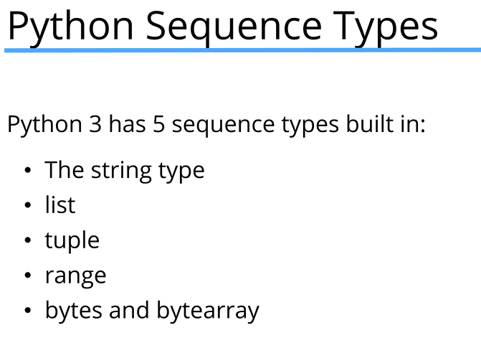

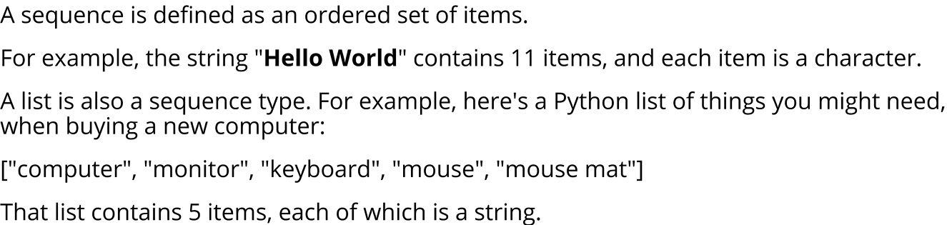
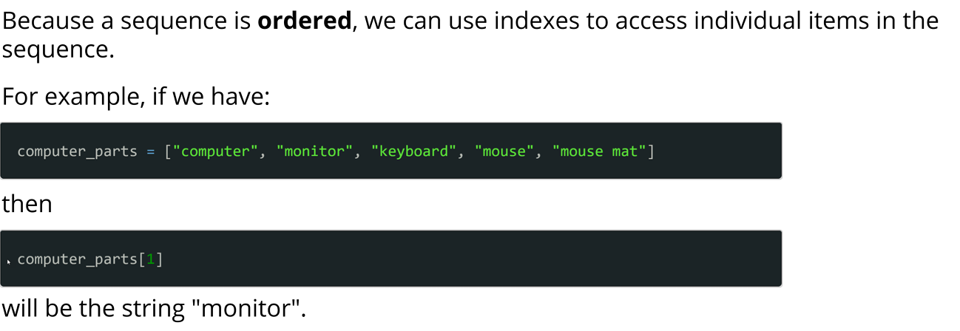
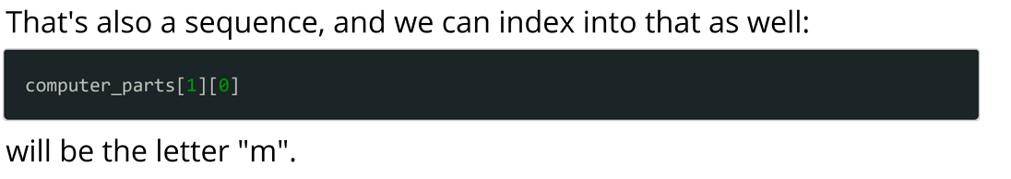
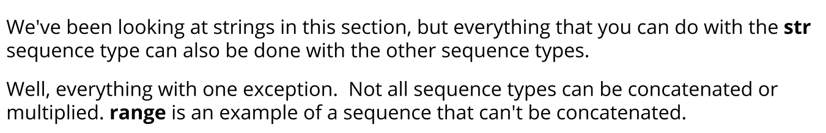
Sequence operators

string1 = "he's "
string2 = "probably "
string3 = "pining "
string4 = "for the fjords"

# Concatenation using the + operator and implicit concatenation
print(string1 + string2 + string3 + string4) #he's probably pining for the fjords

#In Python, string literals placed next to each other are automatically concatenated.
print("he's " "probably " "pining " "for the fjords") #he's probably pining for the fjords

variable = "he's " "probably " "pining " "for the fjords"
print(variable) #he's probably pining for the fjords

#In Python, you can also use the * operator to repeat strings.
print("Hello " * 5) #Hello Hello Hello Hello Hello

print("Hello " * (5 + 4)) #Hello Hello Hello Hello Hello Hello Hello Hello Hello
print("Hello " * 5 + "4") #Hello Hello Hello Hello Hello 4

#Check if a substring exists within a string using the 'in' operator.
today = "Friday"
print("day" in today) #True
print("fri" in today) #False (case-sensitive)

String replacement fields

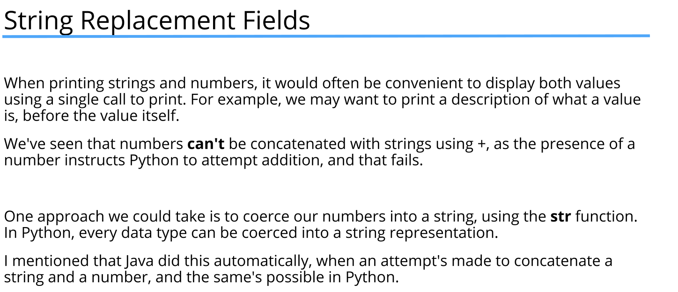
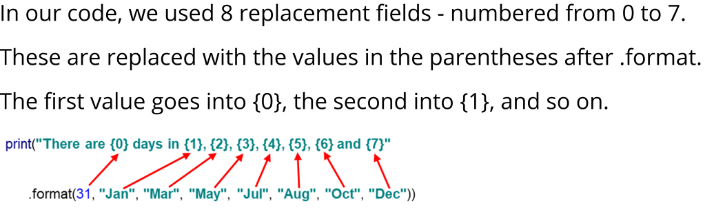
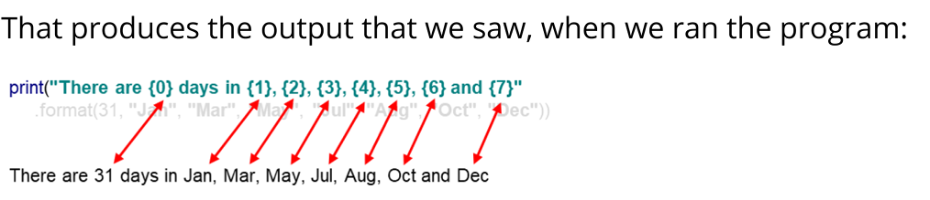
age = 24
#Every data type can be converted to string using str() function
print("My age is " + str(age) + " years") # Output: My age is 24 years
#But if we use a lot of variables then it becomes hard to read
#Instead we can use .format() function
#{} is used as a placeholder
#Number inside {} represents the index of the value passed in .format()
#The values inside .format() will be placed in the respective placeholders

print("My age is {0} years".format(age)) # Output: My age is 24 years
#Multiple placeholders can be used
print("There are {0} days in {1}, {2}, {3}, {4}, {5}, {6} and {7}."
.format(31, "January", "March", "May", "July", "August", "October", "December"))
# Output: There are 31 days in January, March, May, July, August, October and December.

#The order of indexes inside placeholders can be changed
print("Jan: {2}, Feb: {0}, Mar: {2}, Apr: {1}, May: {2}, Jun: {1}, Jul: {2}, Aug: {2}, Sep: {1}, Oct: {2}, Nov: {1}, Dec: {2}"
.format(28, 30, 31))
# Output: Jan: 31, Feb: 28, Mar: 31, Apr: 30, May: 31, Jun: 30, Jul: 31, Aug: 31, Sep: 30, Oct: 31, Nov: 30, Dec: 31

#.format() can be used with triple quotes as well
print("""Jan: {2}
Feb: {0}
Mar: {2}
Apr: {1}
May: {2}
Jun: {1}
Jul: {2}
Aug: {2}
Sep: {1}
Oct: {2}
Nov: {1}
Dec: {2}"""
.format(28, 30, 31))
#Output:
#Jan: 31
#Feb: 28
#...

String formating

for i in range(1, 13):
#To set the field width use a number after the colon
#By default the text is right aligned
#To right align the text use the > character
print("No. {0:2} squared is {1:3} and cubed is {2:4}"
.format(i, i**2, i**3))

print()

for i in range(1, 13):
#To left align the text use the < character
#To center align the text use the ^ character
print("No. {0:2} squared is {1:<3} and cubed is {2:^4}"
.format(i, i**2, i**3))

print()

print("Pi is approximately {0:12}".format(22/7))
#To specify the number of digits after
# the decimal point use . followed by the number of digits
#f is used to format a number as a fixed point number
#Maximum precision for a float is 50 digits
print("Pi is approximately {0:12f}".format(22/7))
print("Pi is approximately {0:12.50f}".format(22/7))
print("Pi is approximately {0:52.50f}".format(22/7))
print("Pi is approximately {0:62.50f}".format(22/7))
print("Pi is approximately {0:72.50f}".format(22/7))
print("Pi is approximately {0:<72.54f}".format(22/7))

print()

for i in range(1, 13):
#You can also omit the positional arguments
#In this case the arguments are used in the order they are passed to format()
#You can still use the field width specifiers
print("No. {} squared is {} and cubed is {:<4}"
.format(i, i**2, i**3))

F-strings

age = 24
name = "Alice"
age_in_words = "2 years"

# Using f-strings to embed expressions inside string literals
print(name + f" is {age} years old.") # Output: Alice is 24 years old.
print(f"Pi is approximately {22 / 7:12.50f}.")
# Output: Pi is approximately 3.142857142857142857142857142857142857142857142857142857142857.

pi = 22/7

print(f"Pi is approximately {pi:.50f}.")
# Output: Pi is approximately 3.14285714285714283596573873136383104324340820312500.

String interpolation in Python 2

#String interpolation is used in Python 2
#using the % operator and in Python 3 using the str.format() method
#or f-strings (formatted string literals).
#In Python 3 % operator is still supported but is deprecated in favor of
#and could be removed in future versions.

age = 24

print("My age is %d years." % age) # Output: My age is 24 years.

major = "years"
minor = "months"

print("My age is %d %s and %d %s." % (age, major, 6, minor))
# Output: My age is 24 years and 6 months.
print("PI is approximately %60.50f." % (22 / 7))

